Exploratory Data Analysis

Objective:

Analyze the available project budget for 2024 compared to multi-year capital project budgets, focusing on service categories, budget allocation, and percentage contributions.

1. Data Sources

Raw Data: Stored in an S3 bucket named multiyear-raw-mg.

Processed Data: Stored in the transformed S3 bucket multiyear-trf-mg after cleaning.

2. Data Profiling

Using AWS DataBrew:

Identified missing values and data inconsistencies during profiling.

Observed key insights about data distribution, providing an overview of budget categories and their significance.

Insight: Data profiling is vital to highlight discrepancies and ensure the dataset is well-prepared for downstream processes.

3. Data Cleaning

Key tasks completed:

Column renaming for consistency (e.g., making column names clear and uniform).

Irrelevant column removal, focusing on key fields like budget amount and service categories.

Insight: Cleaning ensured a more streamlined and focused dataset for analysis. Handling redundancies reduces complexity for ETL processes.

4. Trends Observed in Capital Budgets

Analyzing how the 2024 available budget compares with previous multi-year authorized funds reveals:

Service Categories with High Budget Allocation (Multi-Year):

Sectors like water, sewage, and drainage, streets, housing, and public safety exhibit significantly larger authorized multi-year capital budgets compared to allocations for 2024.

Variation in Annual Allocation:

2024 allocation shows a relative reduction in funds, suggesting:

Reallocation of funds to other priorities.

Long-term planning necessitating gradual funding.

5. Budget Distribution

Key factors observed in budget allocations:

Critical sectors, including public safety and infrastructure, show steady or increasing funding due to their necessity in long-term public service enhancements.

2024's lower budget levels highlight balancing short-term needs with the vision for future allocations.

6. Storage Format for Users

The data is stored in:

Parquet format for internal technical operations (optimized storage).

CSV format for easier interpretation by non-technical stakeholders.

7. Insights and Interpretations

Long-term Investments: Multi-year budgets signal prioritization of critical infrastructure development and public welfare.

Strategic Fund Reallocation: Lower available budgets for 2024 indicate potential preparation for unpredictable needs or investment in other key areas.

8. Tools and Technologies Used

S3 Buckets and AWS DataBrew for storage and profiling.

AWS Glue ETL Pipelines for efficient processing and automation.

ETL Process Insight: The inclusion of a scalable ETL pipeline ensures seamless management of large datasets, reducing manual errors.

Conclusion

This analysis highlights the critical need for a balanced approach in budgeting—addressing immediate concerns while laying the groundwork for sustainable, long-term infrastructure and public services.

Further insights could emerge by integrating visual analytics to compare funding trends over time across categories.

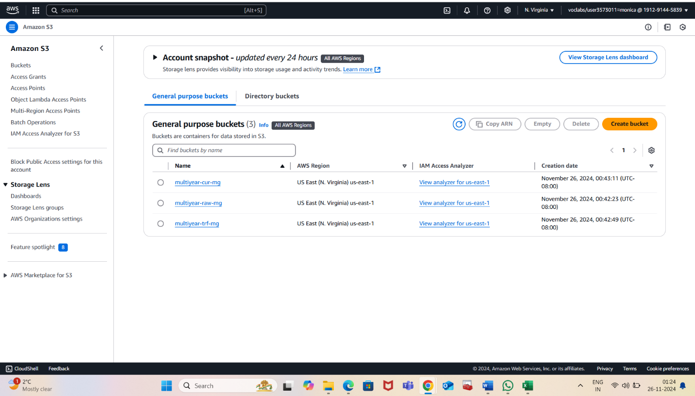

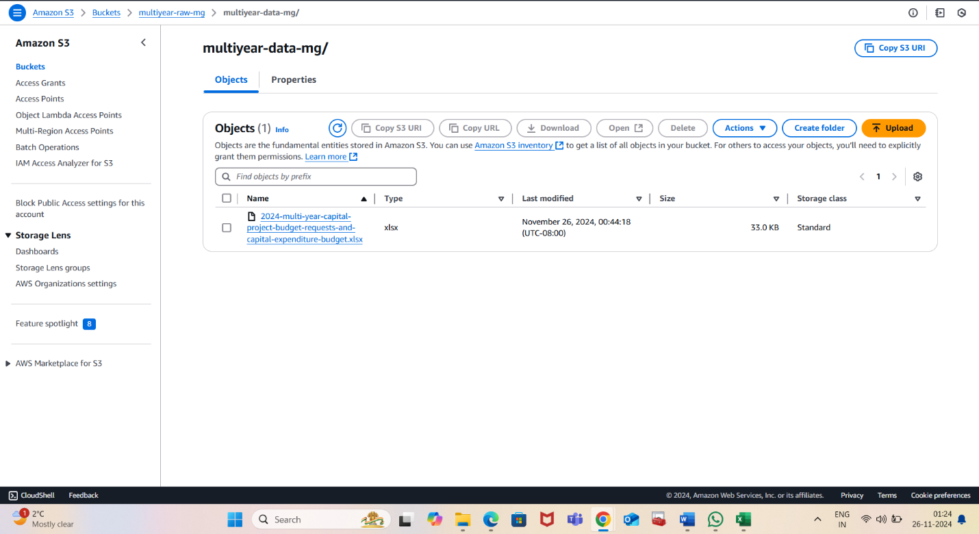

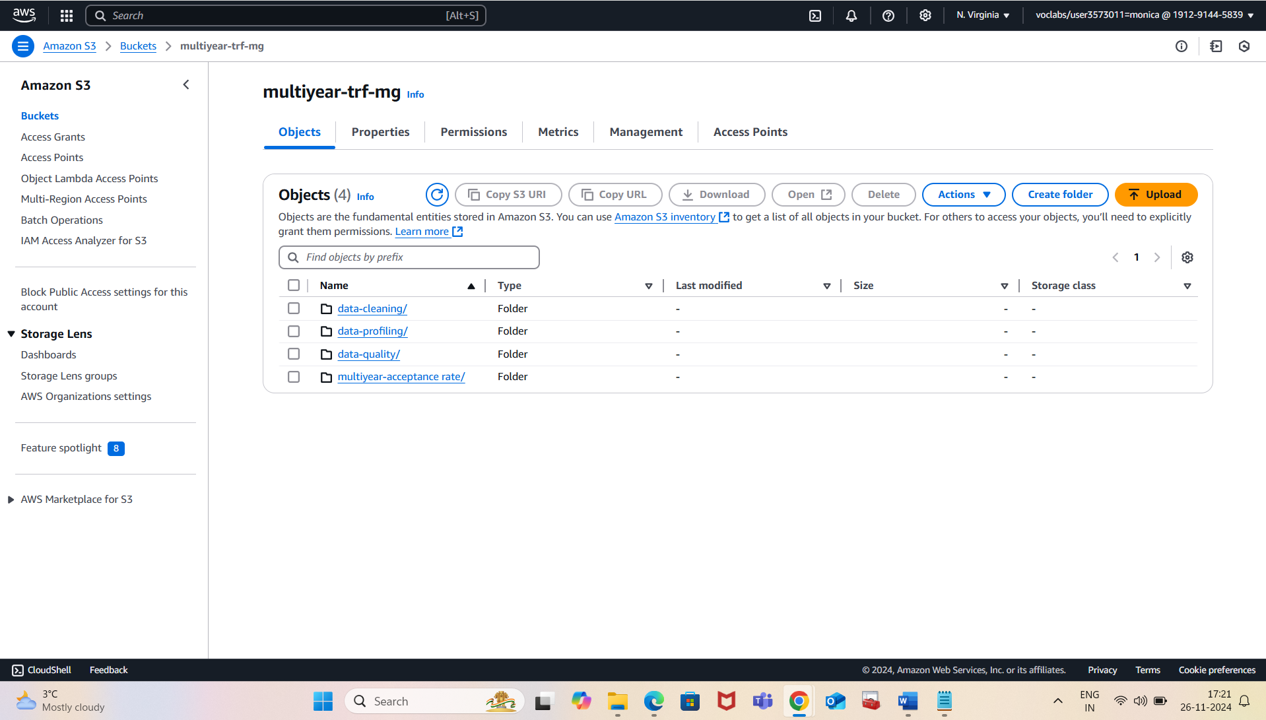

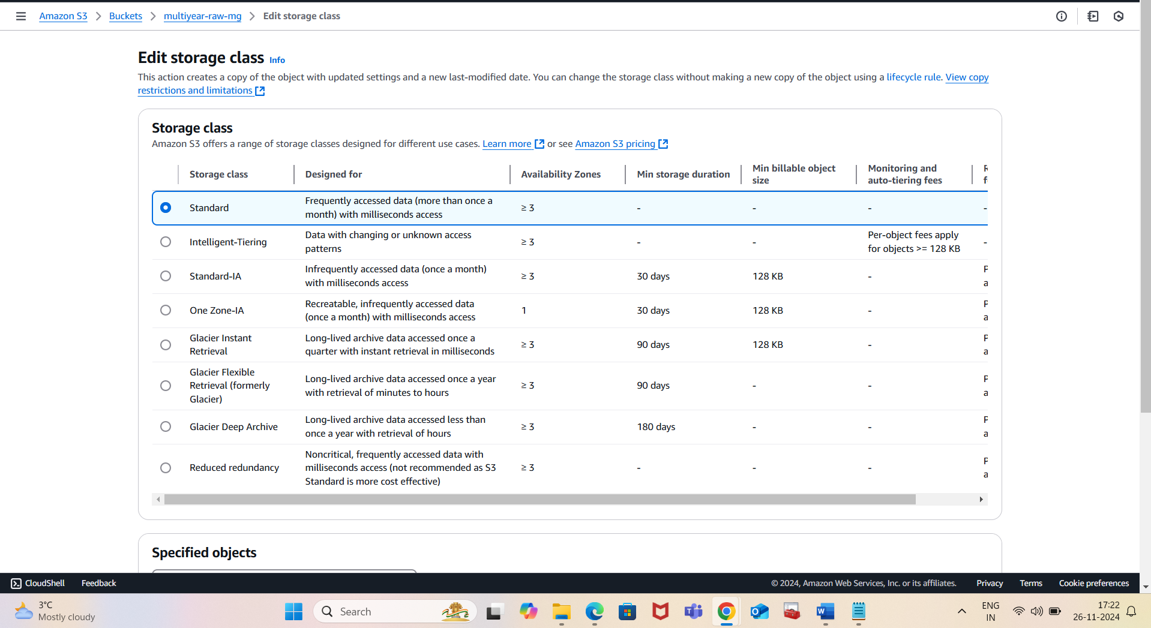

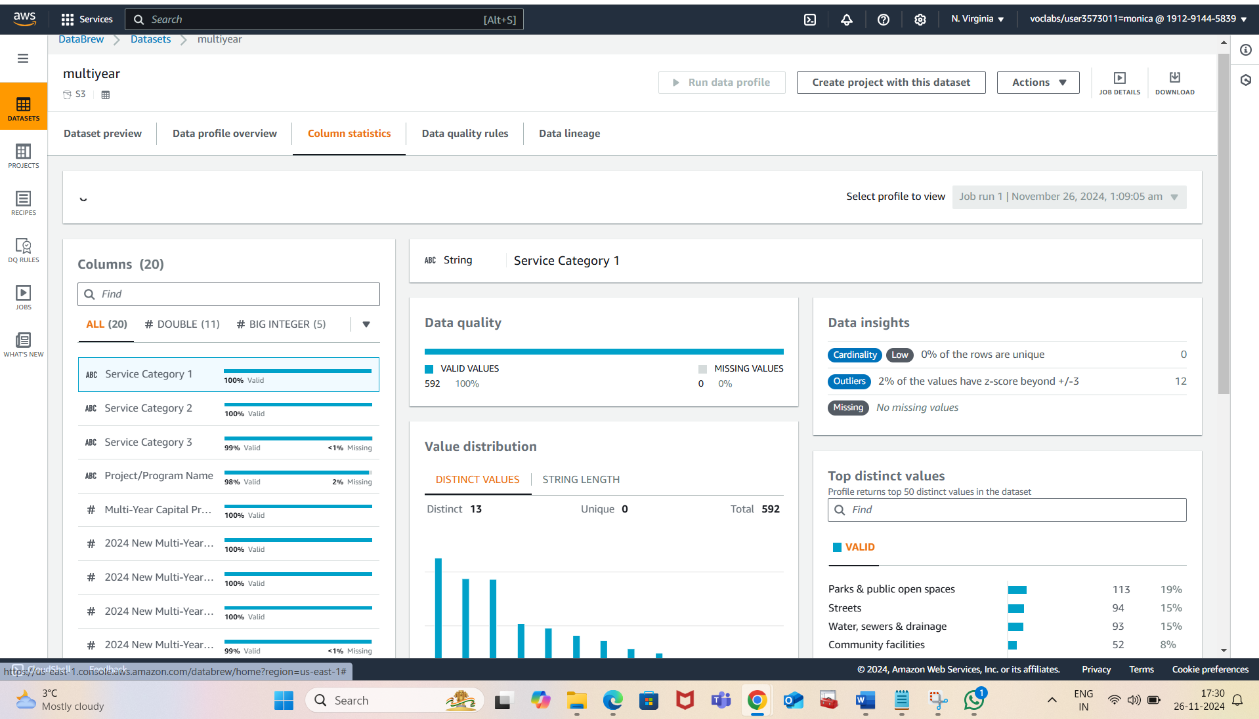

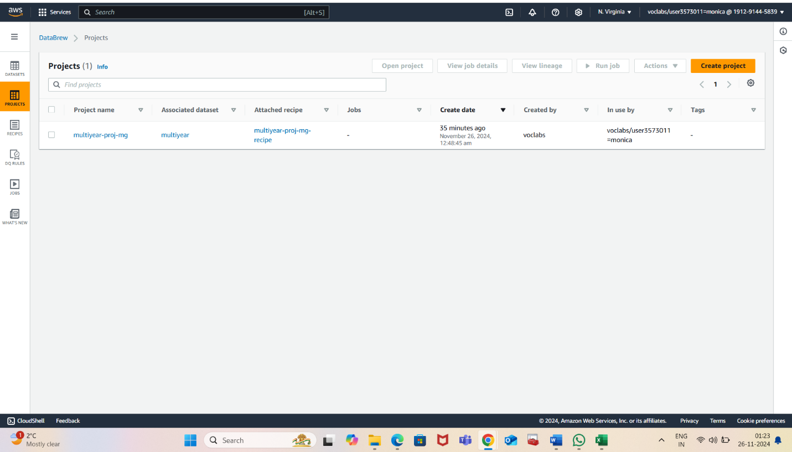

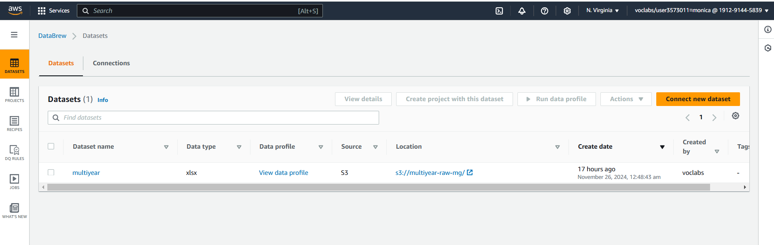

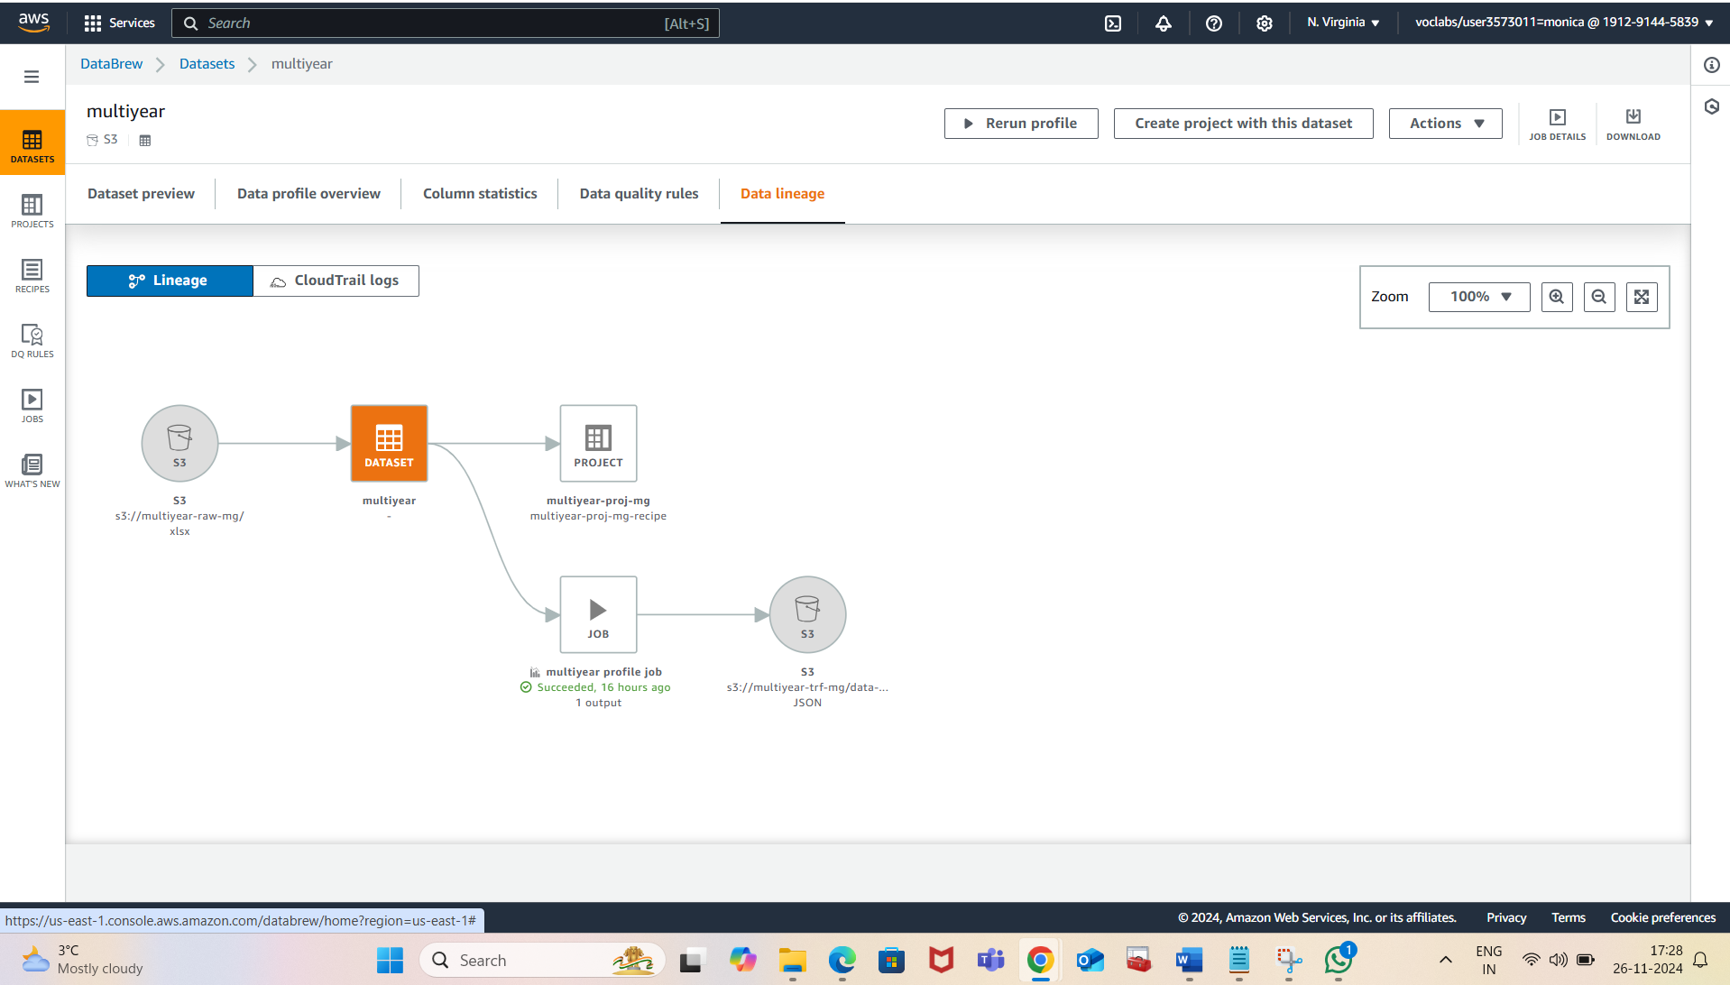

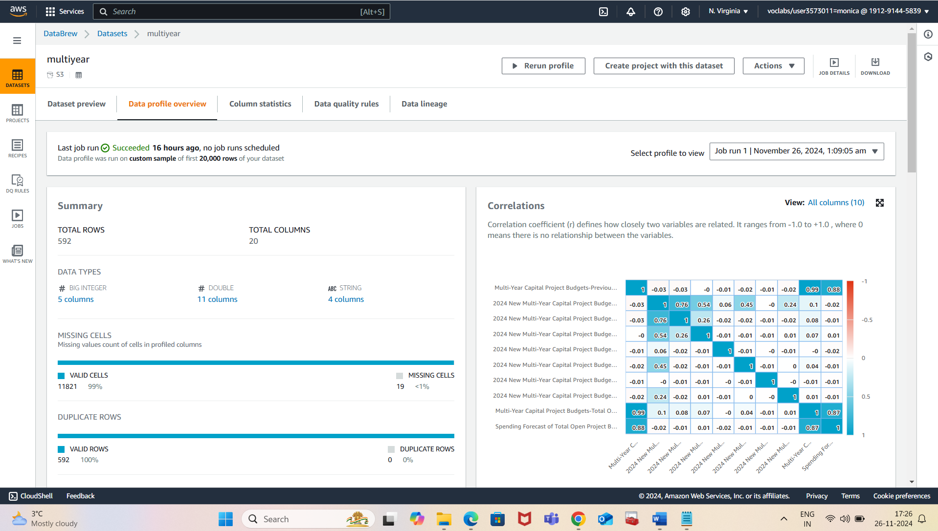

Descriptive Analysis

Objective:

To summarize the key details of the capital project budget for 2024, highlighting trends, service priorities, and the methodology used for data management and analysis.

1. Budget Overview

The capital project budget for 2024 includes:

Spending projections for previously approved multi-year projects up to 2023.

New funding requests for projects outlined in the 2023–2026 Capital Plan.

Anticipated expenses for projects in the 2024–2028 period.

Key Insight:

The 2024 budget consolidates both unspent funds from prior years and fresh allocations, ensuring continuity across ongoing and upcoming projects.

2. Allocation Patterns

Service Categories:

Prioritized areas such as water, sewage and drainage, streets, housing, and public safety received higher long-term allocations compared to the available budget for 2024.

The difference in allocation reflects the critical nature of these sectors for public infrastructure and safety.

Budget Discrepancies:

Multi-year capital budgets show substantial funding, while 2024 focuses on meeting immediate priorities while reserving funds for future projects.

3. Data Management Strategy

Data Sources:

Raw and transformed datasets were stored in separate S3 buckets to ensure a clear workflow and safeguard the integrity of the original data:

Raw Data Bucket: multiyear-raw-mg.

Transformed Data Bucket: multiyear-trf-mg.

Data Profiling and Cleaning:

Profiling conducted via AWS DataBrew revealed missing values, redundant columns, and inconsistencies.

Cleaning involved renaming columns, removing irrelevant fields, and formatting adjustments.

Insight:

Systematic data management enhances transparency and facilitates efficient data analysis by stakeholders.

4. Process Automation with ETL Pipelines

A visual ETL pipeline was created using AWS Glue to:

Load cleaned data into the transformed bucket.

Drop non-essential columns, retaining relevant fields such as service categories and budget allocations.

Aggregate and summarize data by service category and capital budget totals.

Data Output Formats:

Parquet Format: Optimized storage and computation.

CSV Format: Accessibility for non-technical stakeholders.

Insight:

The dual-output strategy ensures usability for diverse stakeholders while preserving storage efficiency for internal use.

5. Trends and Insights from Budget Analysis

Sectoral Priorities:

Long-term investments target foundational services (e.g., public safety, water, and housing).

Reduced annual allocations may reflect a shift toward planning and reserves for future funding needs.

Balancing Short- and Long-term Objectives:

The gap between multi-year budgets and the 2024 available project budget demonstrates the balancing of immediate needs against long-term development goals.

6. Summary Statistics

Capital Funding Insights:

A higher percentage of funds is allocated to previously approved multi-year projects.

New requests from the 2023–2026 Capital Plan are moderate in comparison.

Categorical Patterns:

Specific service categories dominate multi-year allocations (e.g., housing, streets), aligning with government infrastructure priorities.

Key Observations

Strategic planning is evident, emphasizing sustainable budgeting for infrastructure projects.

Data profiling and cleaning ensure reliable datasets, paving the way for insightful analyses.

Leveraging cloud-based tools enhances scalability and reduces manual overhead in data handling.

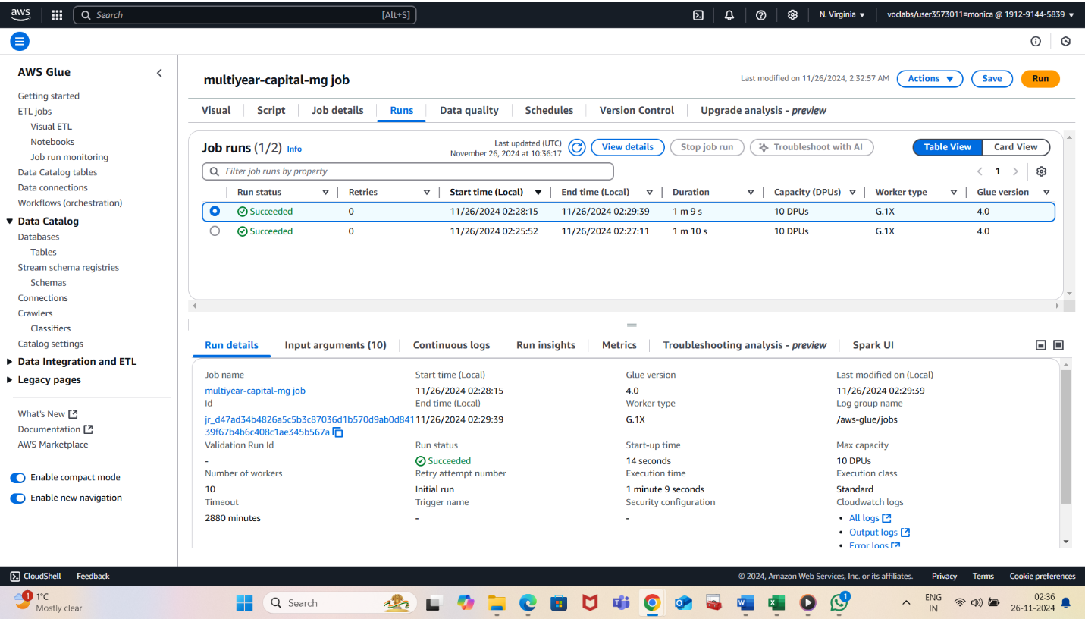

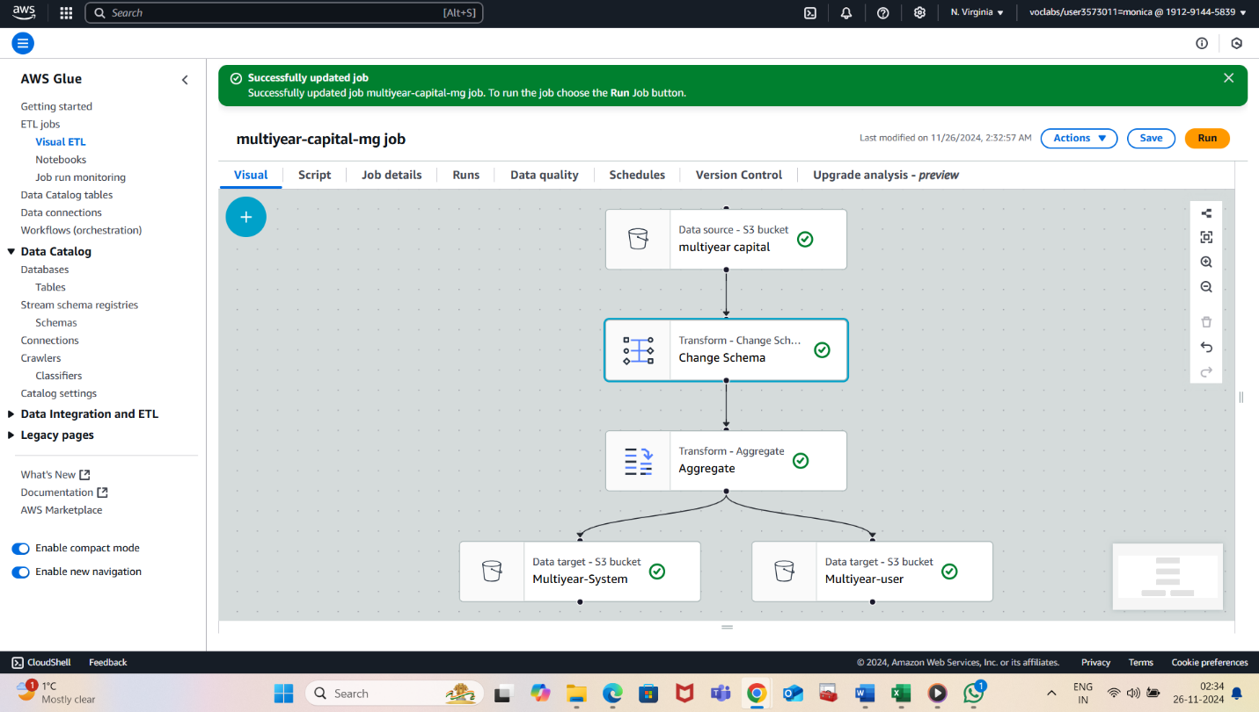

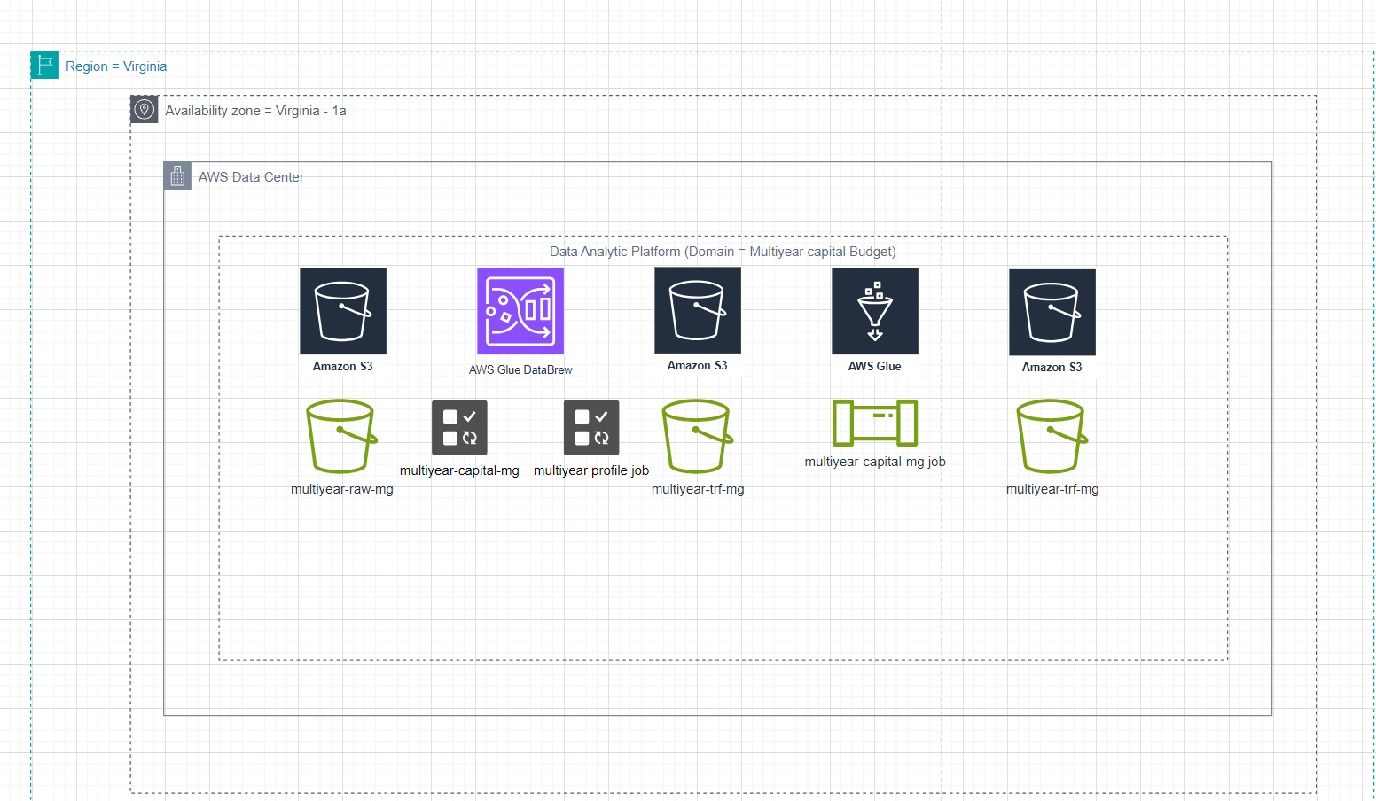

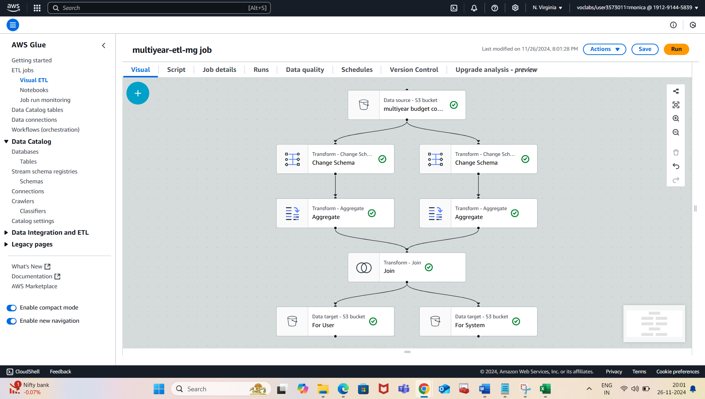

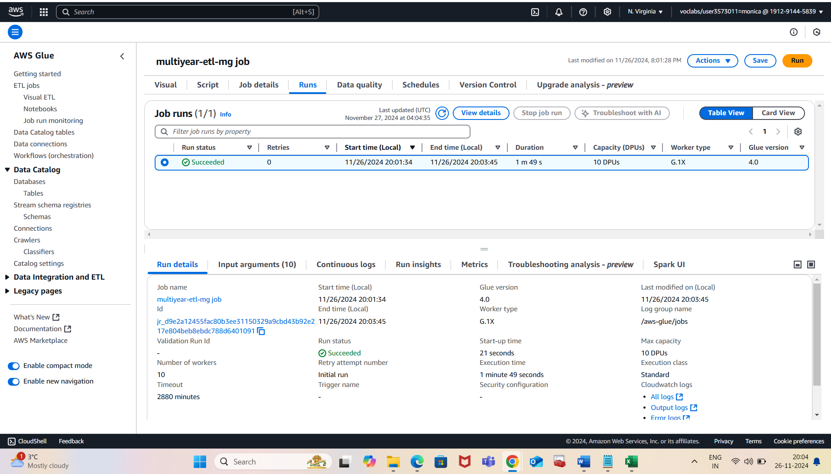

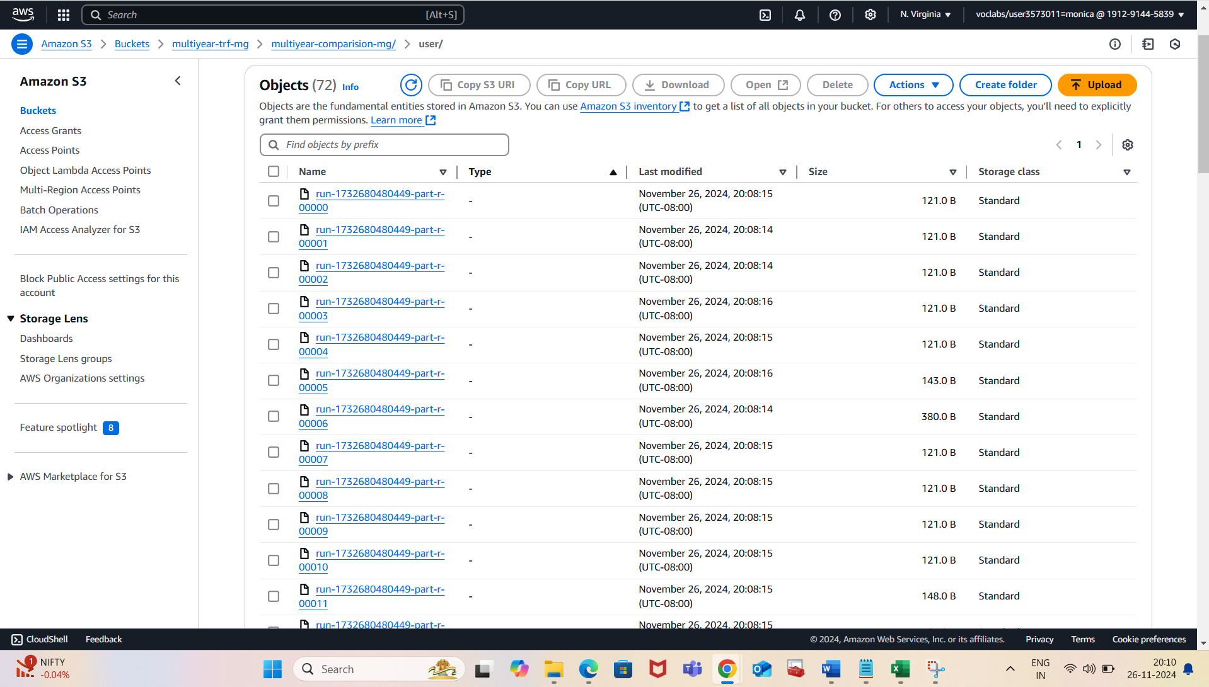

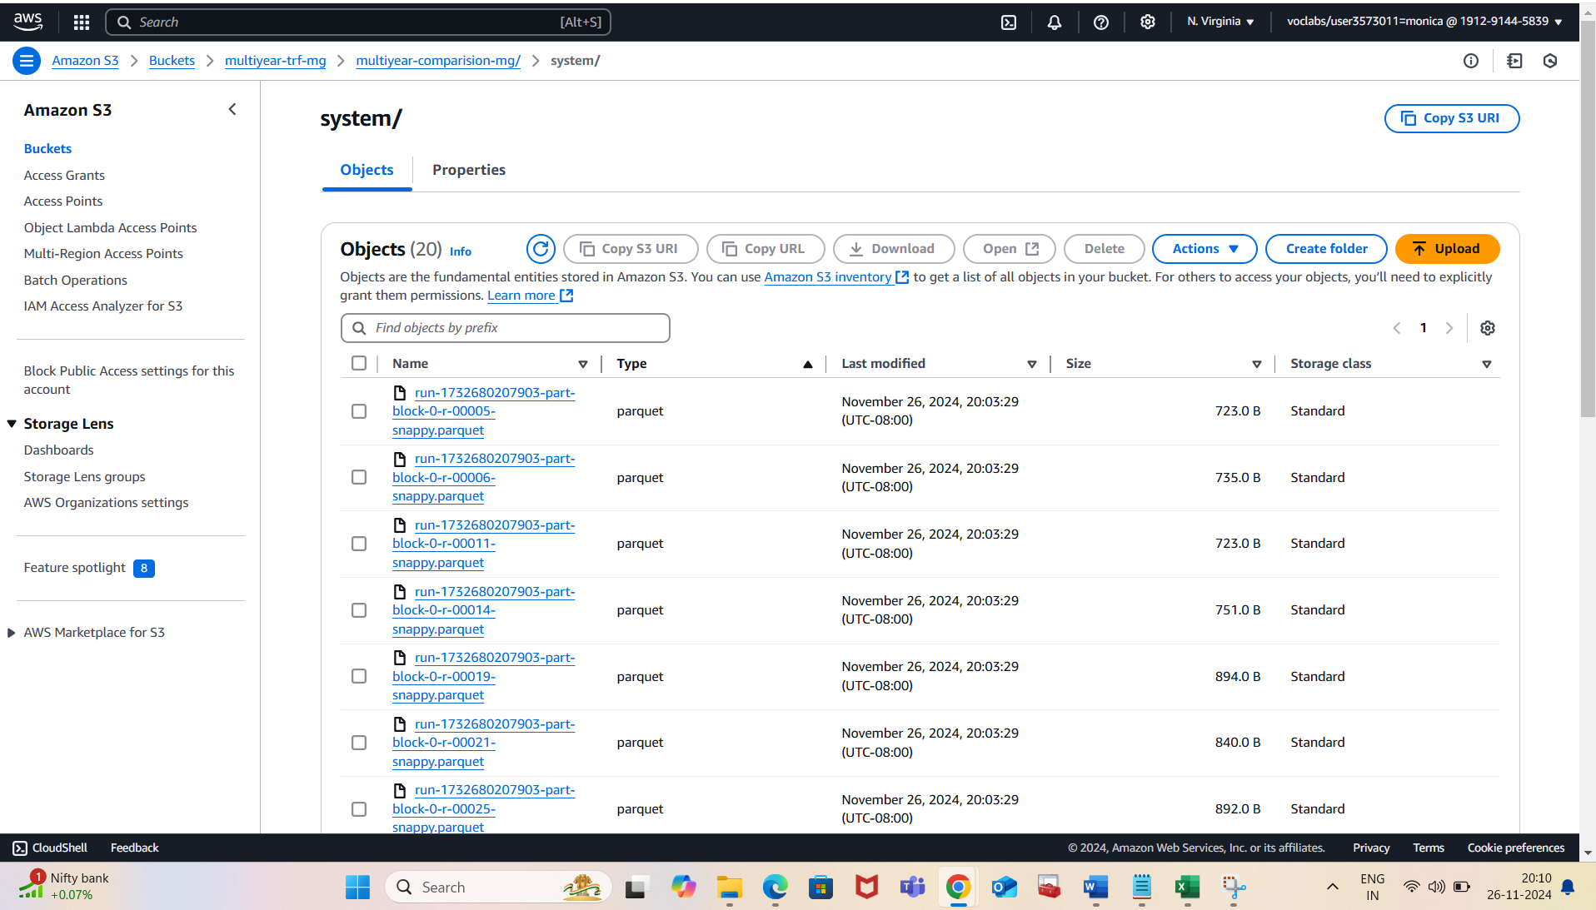

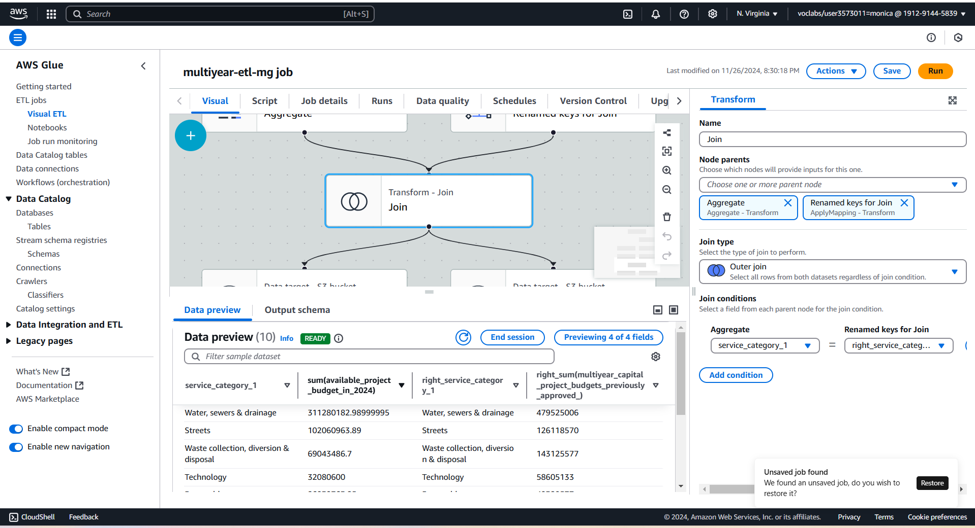

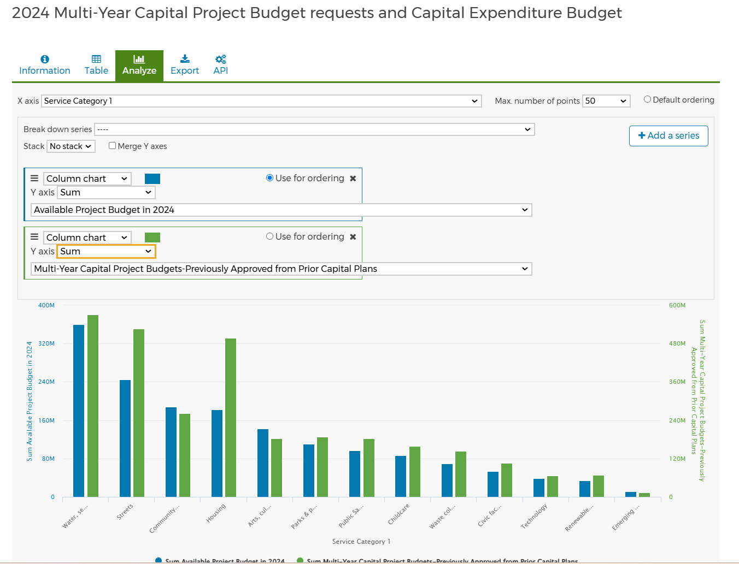

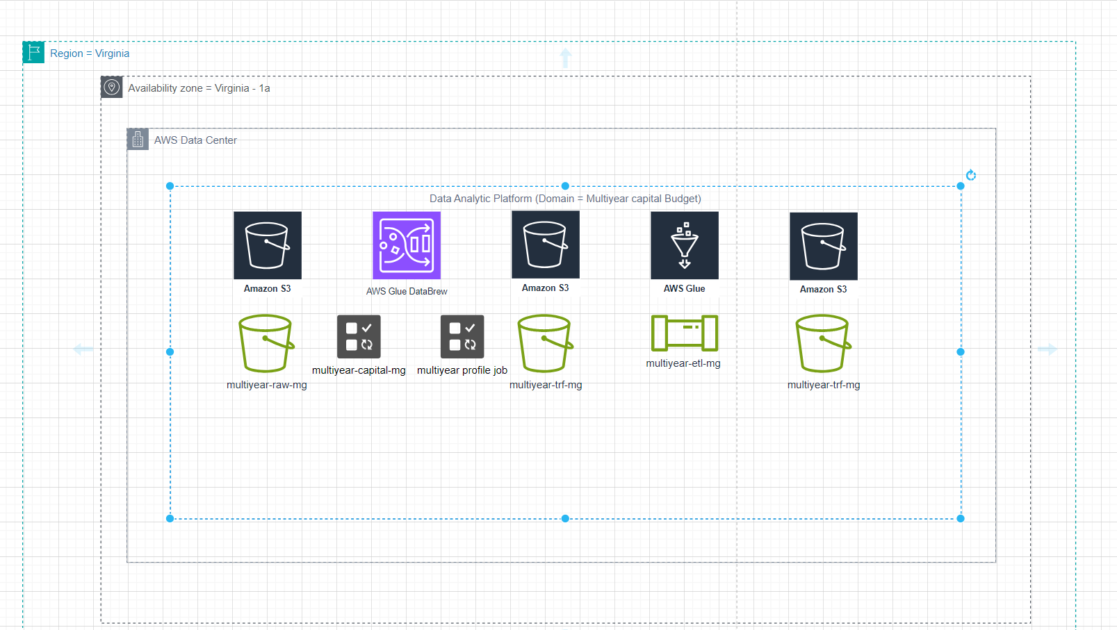

Descriptive Analysis

Objective

To summarize the 2024 annual capital expenditure by region, with a focus on allocation patterns, data management strategies, security protocols, and operational excellence in the context of AWS cloud technologies.

1. Budget Overview

The diagnostic question posed in the document is:

What is the total sum of the 2024 annual capital expenditure by region, and how does it compare to the allocated capital expenditure budget for the same year?

Data Organization:

Raw data stored in an S3 bucket named multiyear-budget-backup.

Transformed data stored in multiyear-budget-region-trf-mg bucket for easier access and analysis.

Key Insight:

Separating raw and transformed data ensures workflow efficiency and data security, safeguarding original datasets while streamlining the transformation process.

2. Data Profiling and Cleaning

DataBrew Profiling: Conducted to highlight:

Missing values, data inconsistencies, and key insights about data distribution.

Cleaning Recipe:

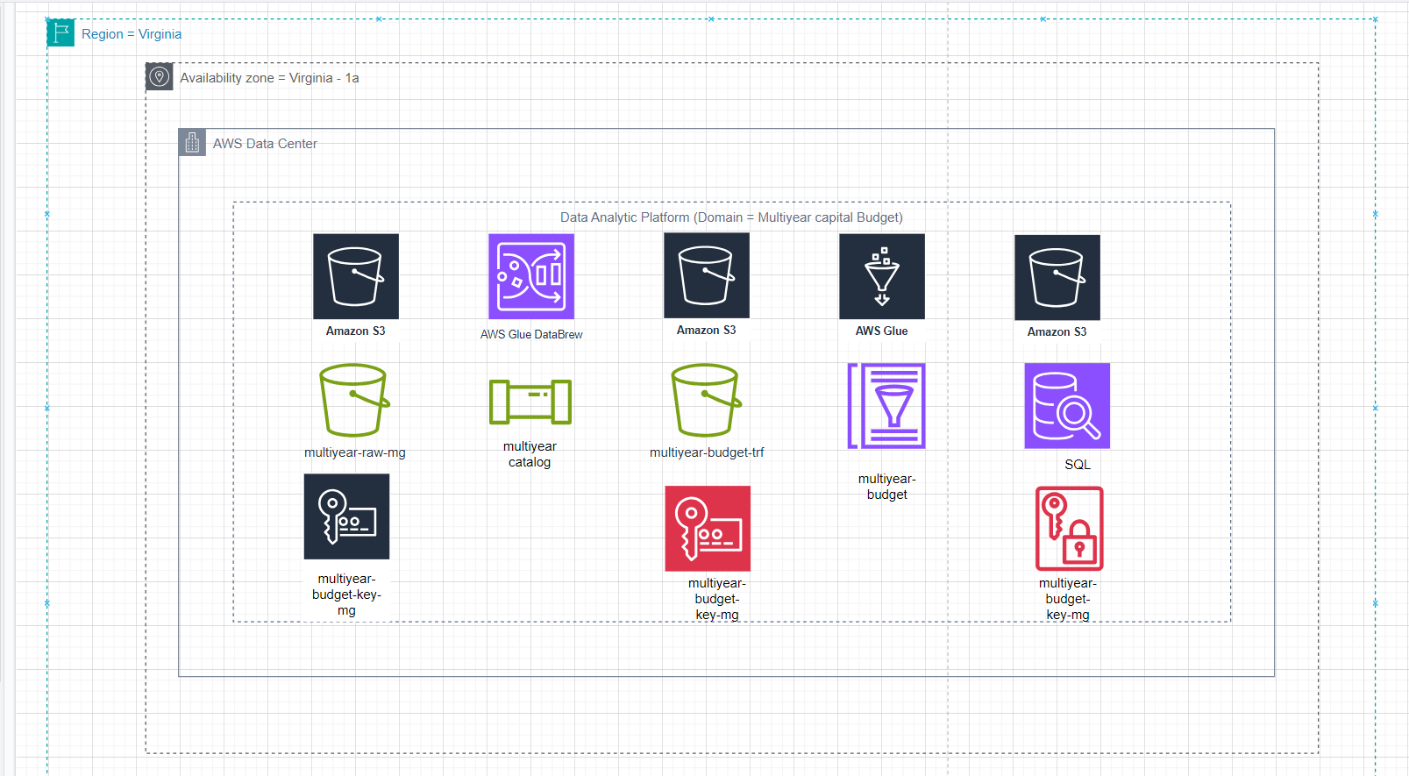

Renamed columns for consistency.

Dropped irrelevant fields, focusing on 2024-specific data for regional capital expenditure.

Key Insight:

A structured cleaning process ensures accurate data analysis and compatibility across analytical workflows.

3. Data Management Strategy

ETL Pipeline: Visualized and implemented using AWS Glue for automation. The pipeline:

Aggregated 2024 annual expenditure by region to calculate total amounts.

Stored transformed outputs in:

Parquet format (optimized for internal storage).

CSV format (easy access for non-technical stakeholders).

Insight:

The dual-output storage format caters to both technical and non-technical user groups, improving stakeholder accessibility and collaboration.

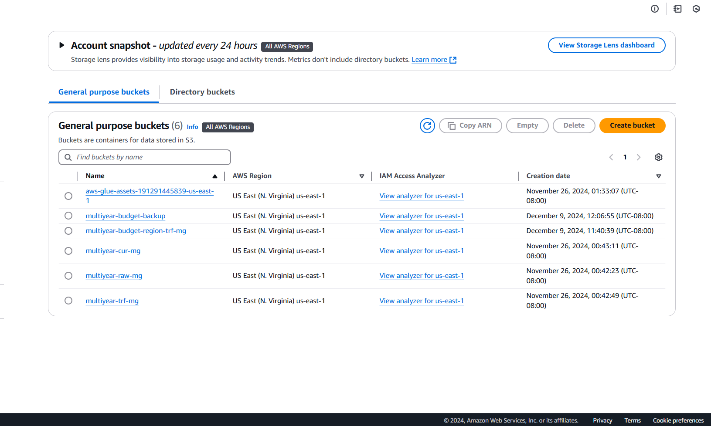

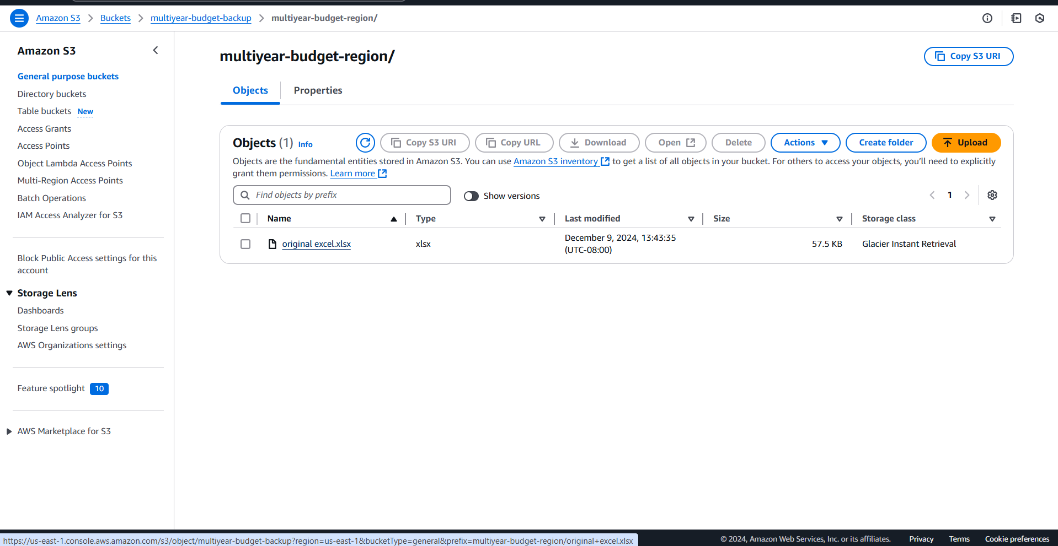

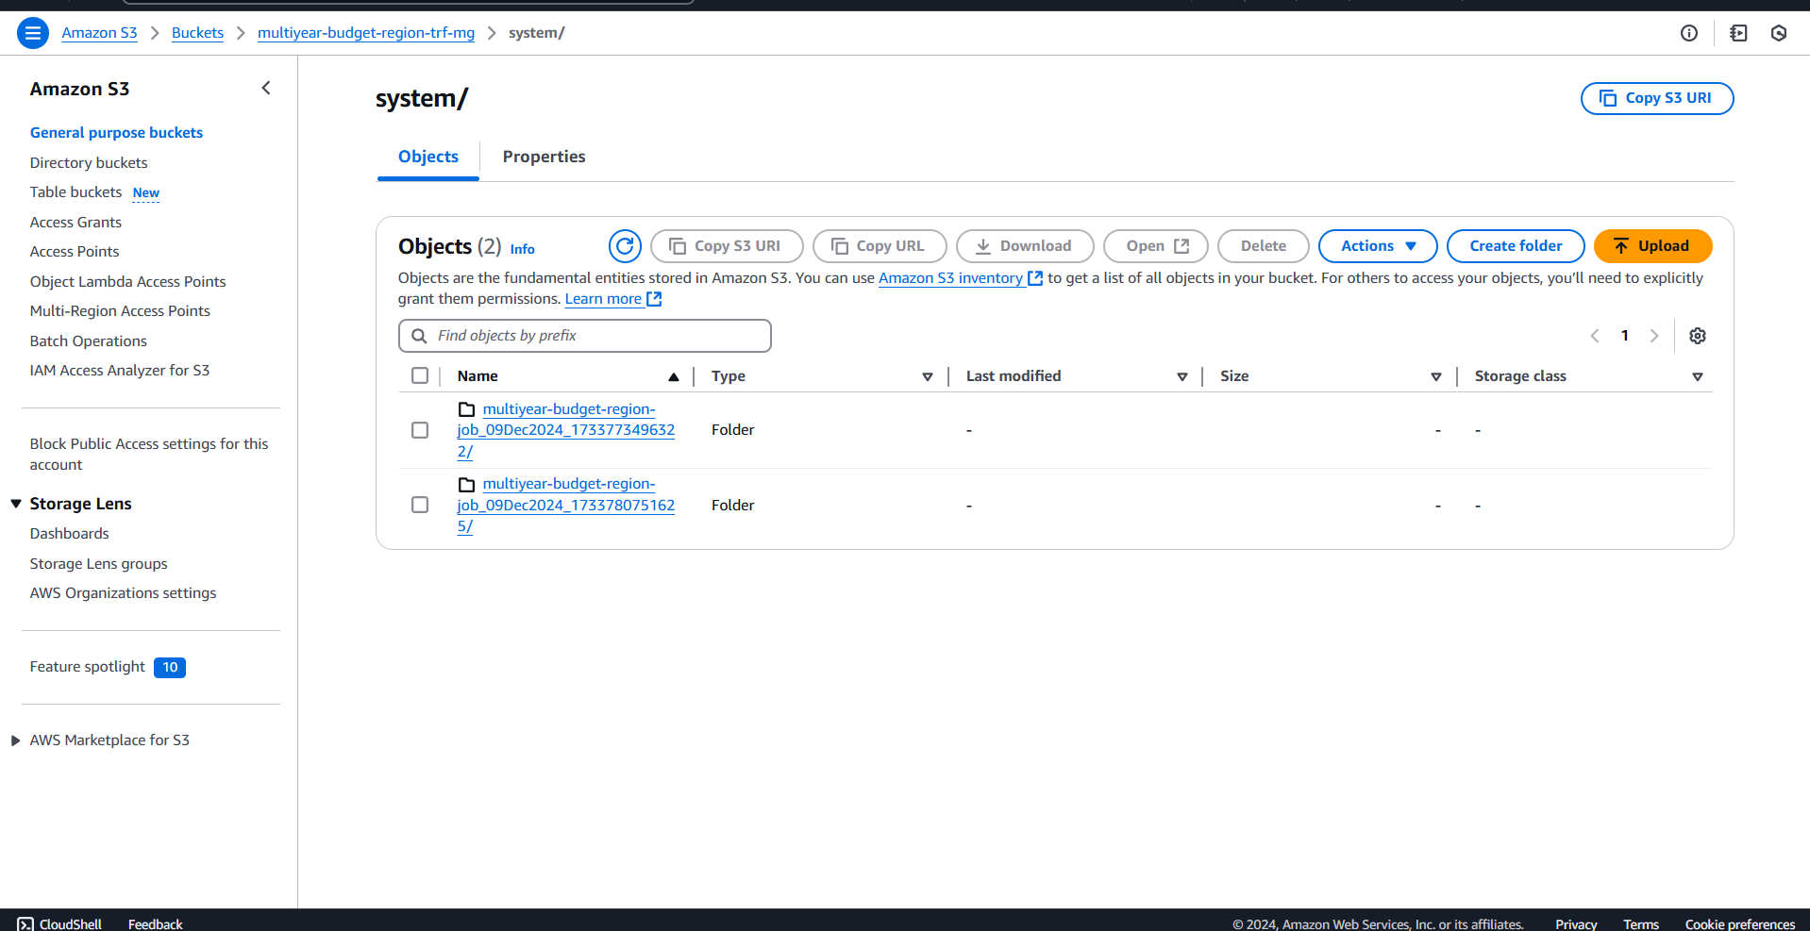

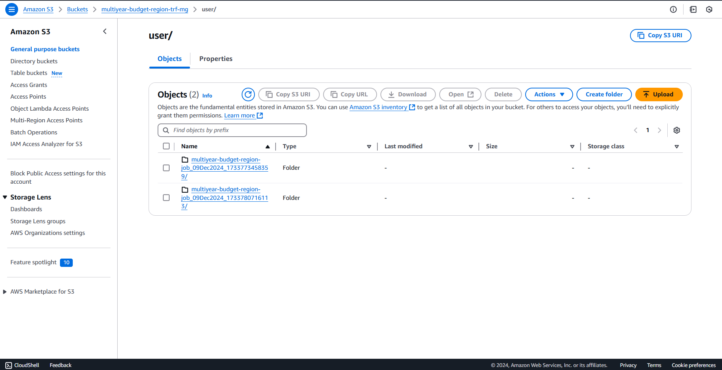

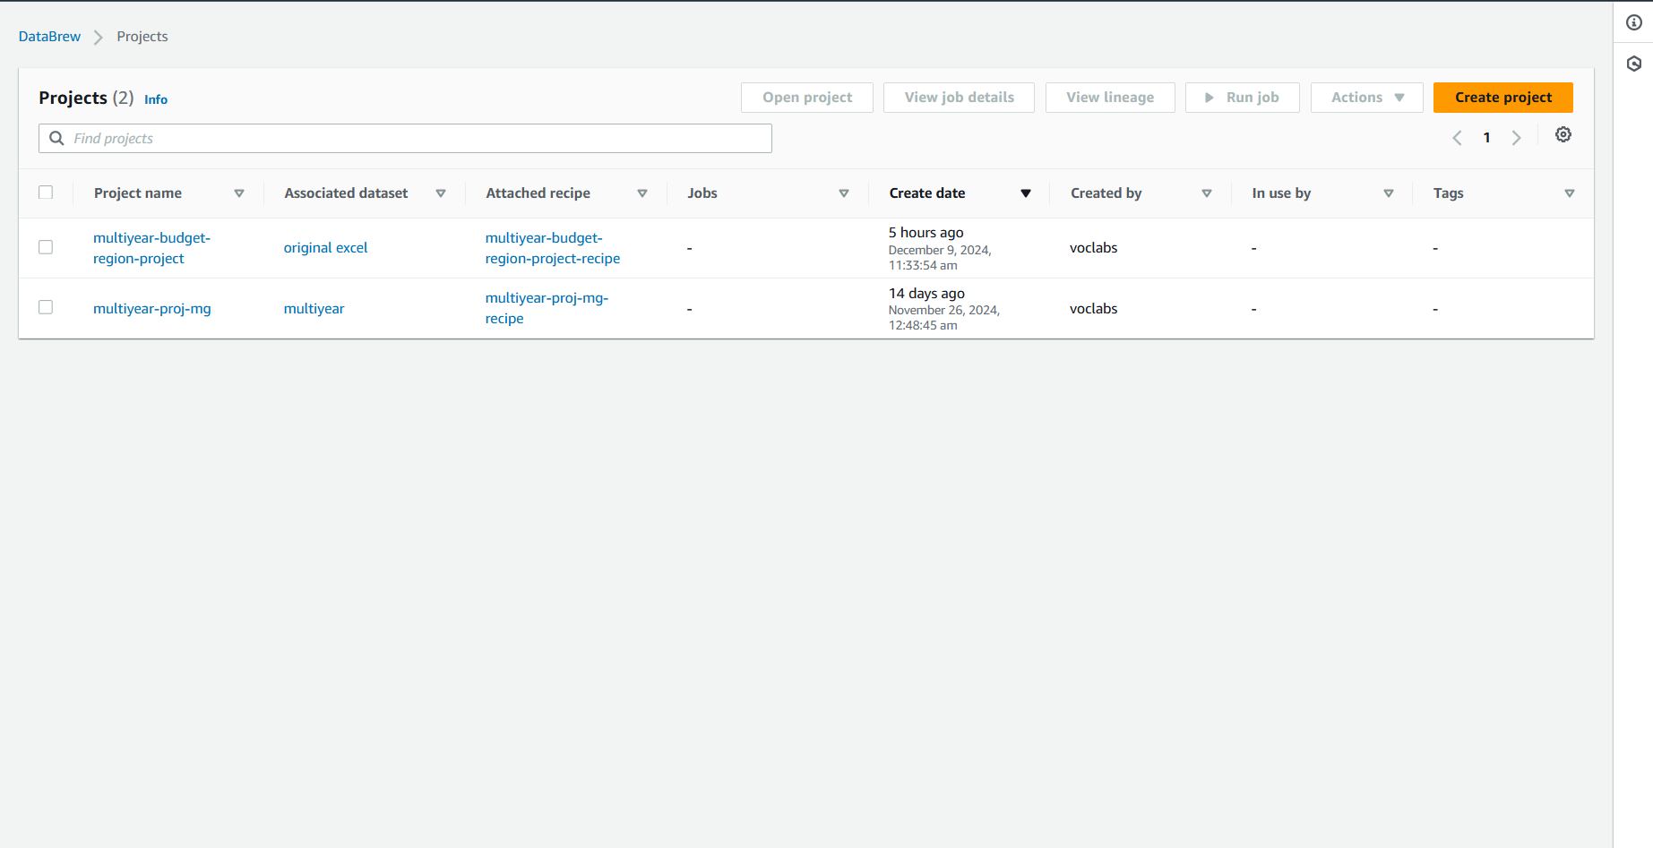

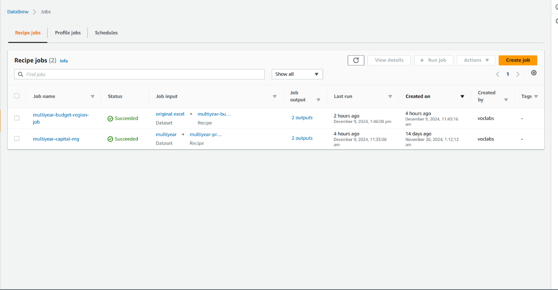

4. Security Measures

Data Encryption: Sensitive data encrypted using AWS KMS to secure storage and access control.

Access Restrictions: Managed through IAM policies to enforce secure data handling.

Logging and Auditing: AWS CloudTrail tracks all activities to ensure compliance, accountability, and error detection.

Key Insight:

Security protocols like KMS and CloudTrail enhance project data governance while preventing unauthorized access and potential vulnerabilities.

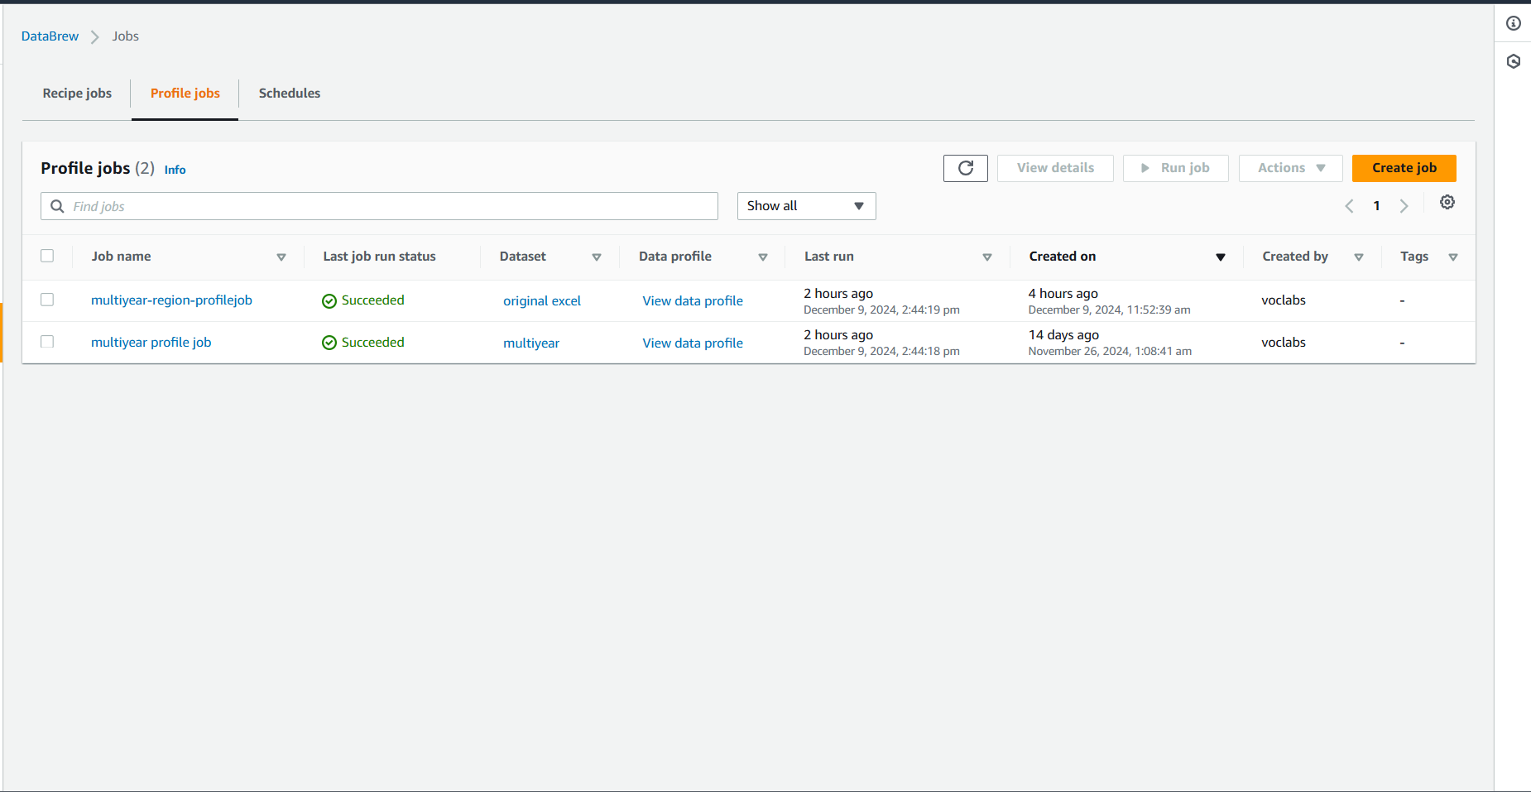

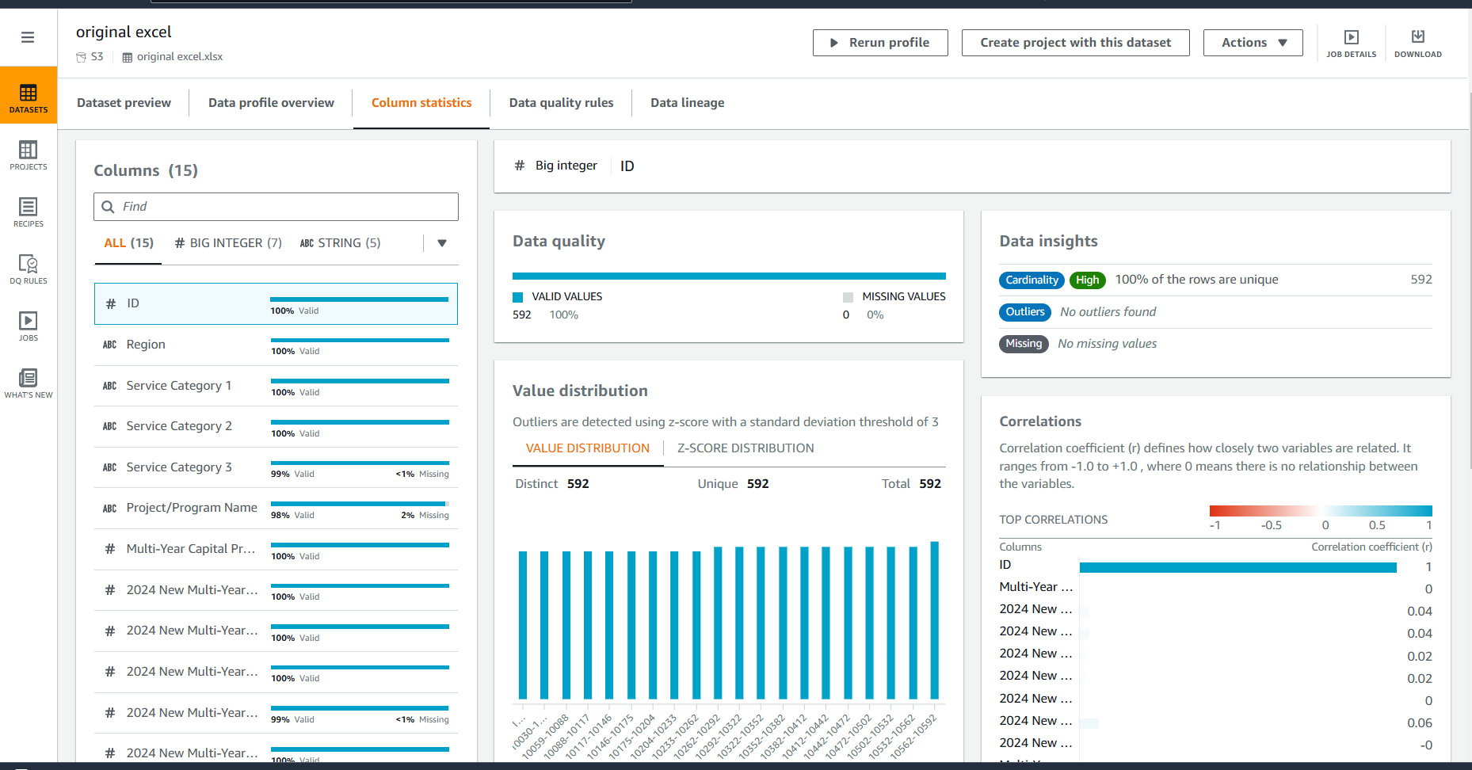

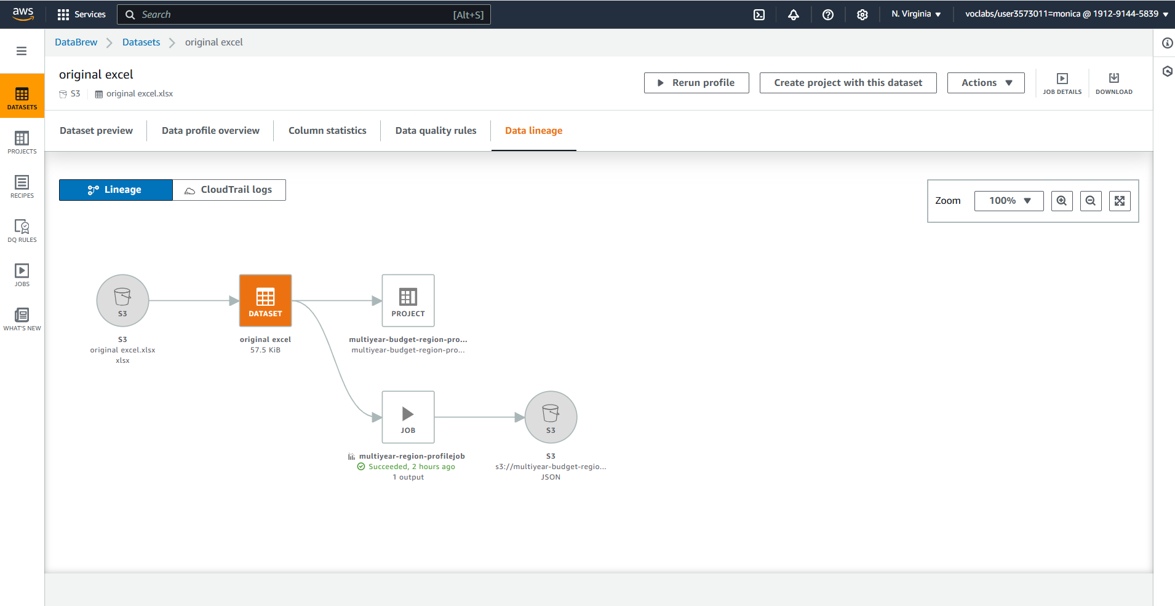

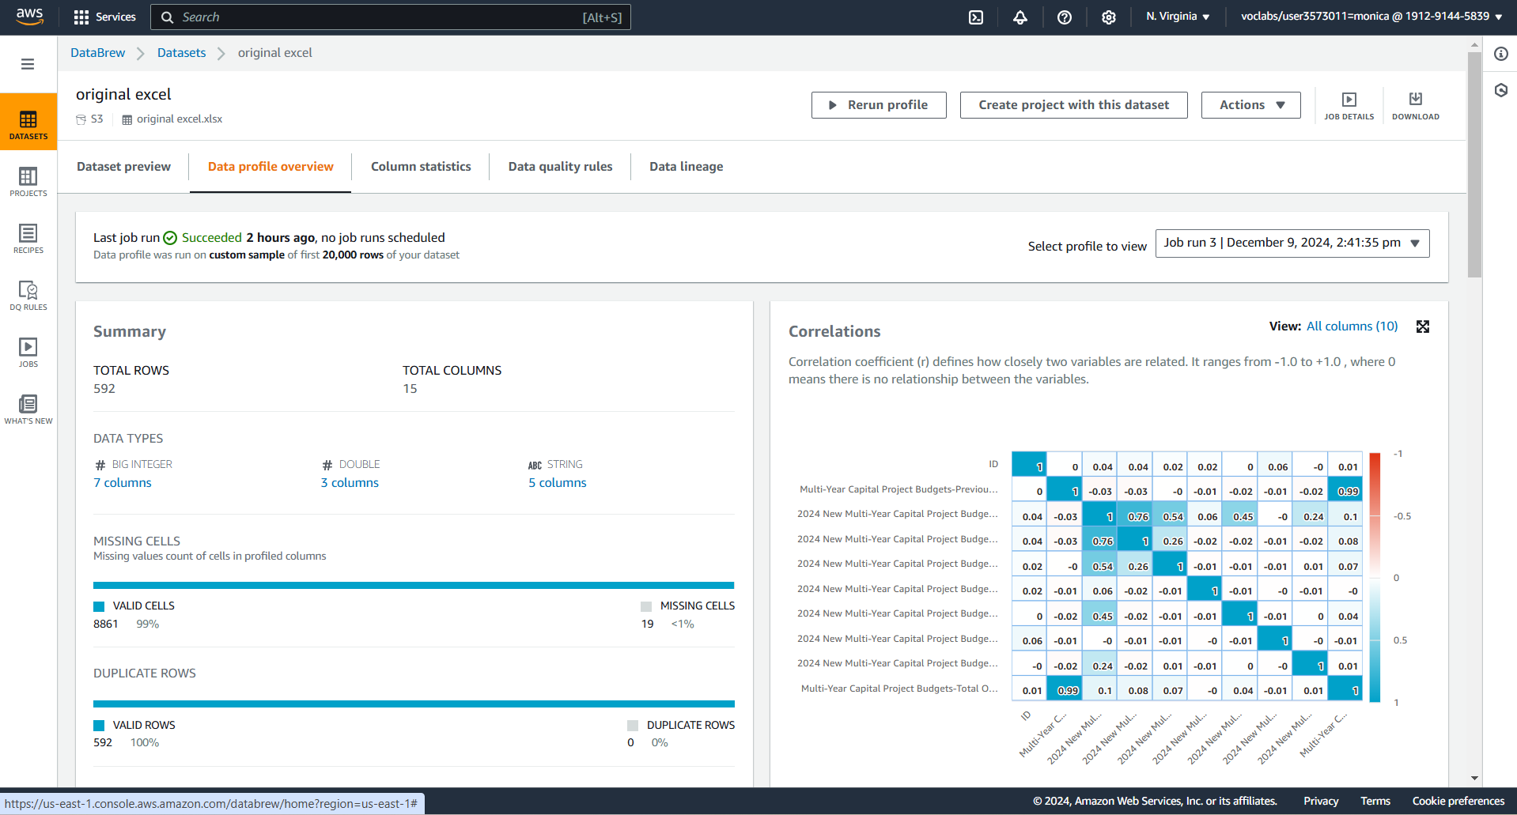

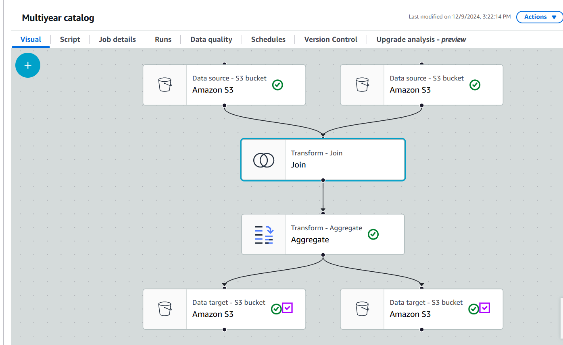

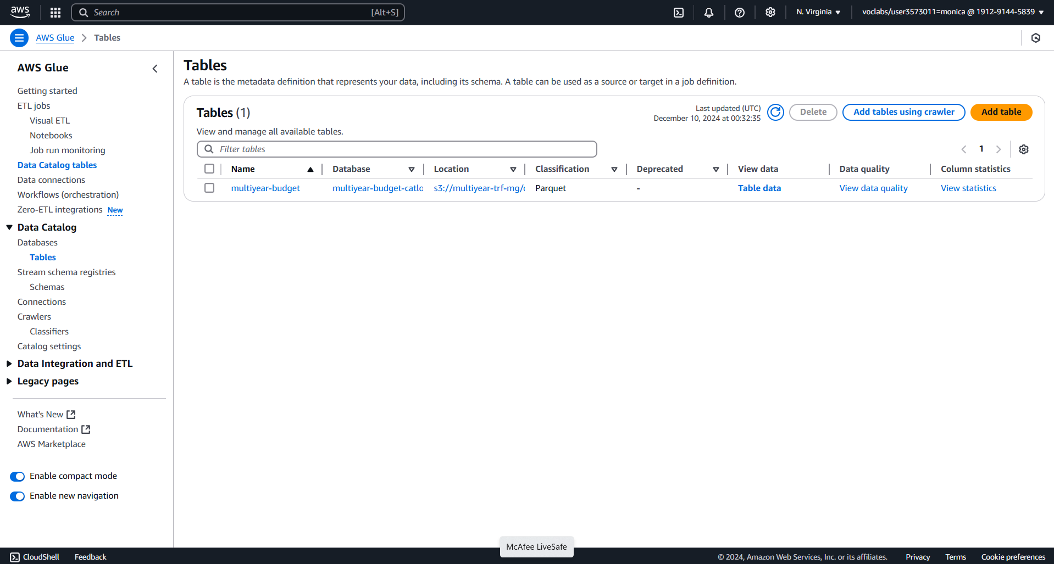

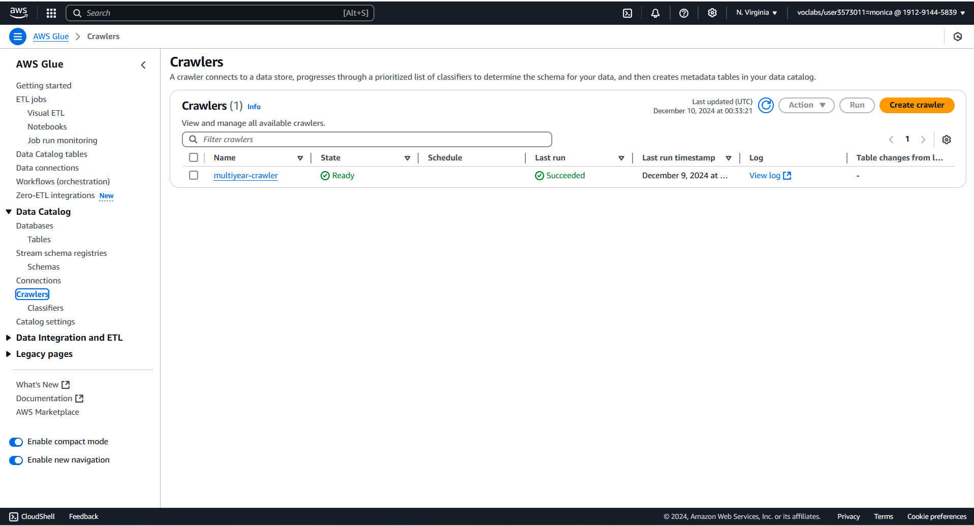

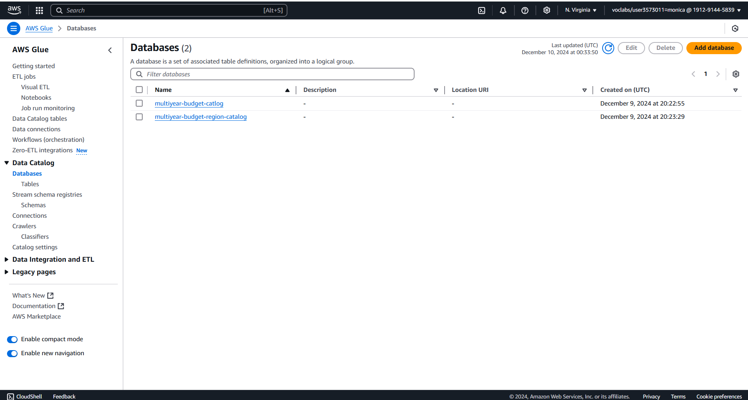

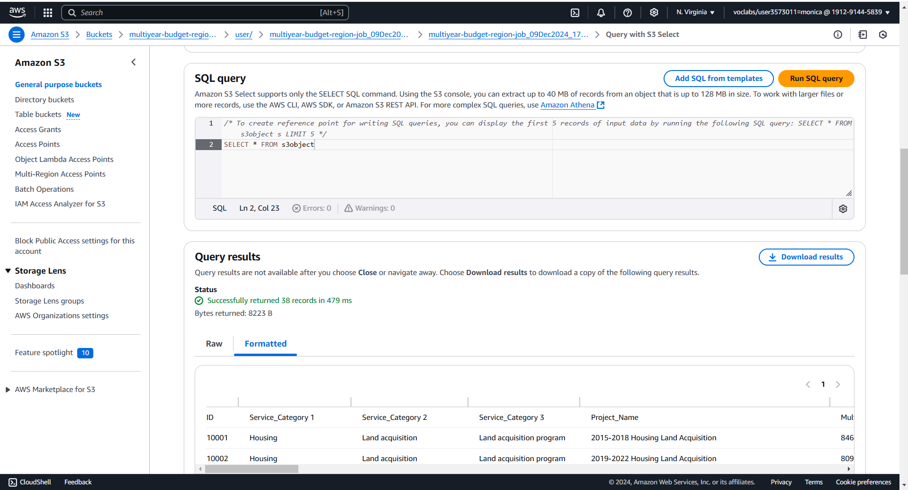

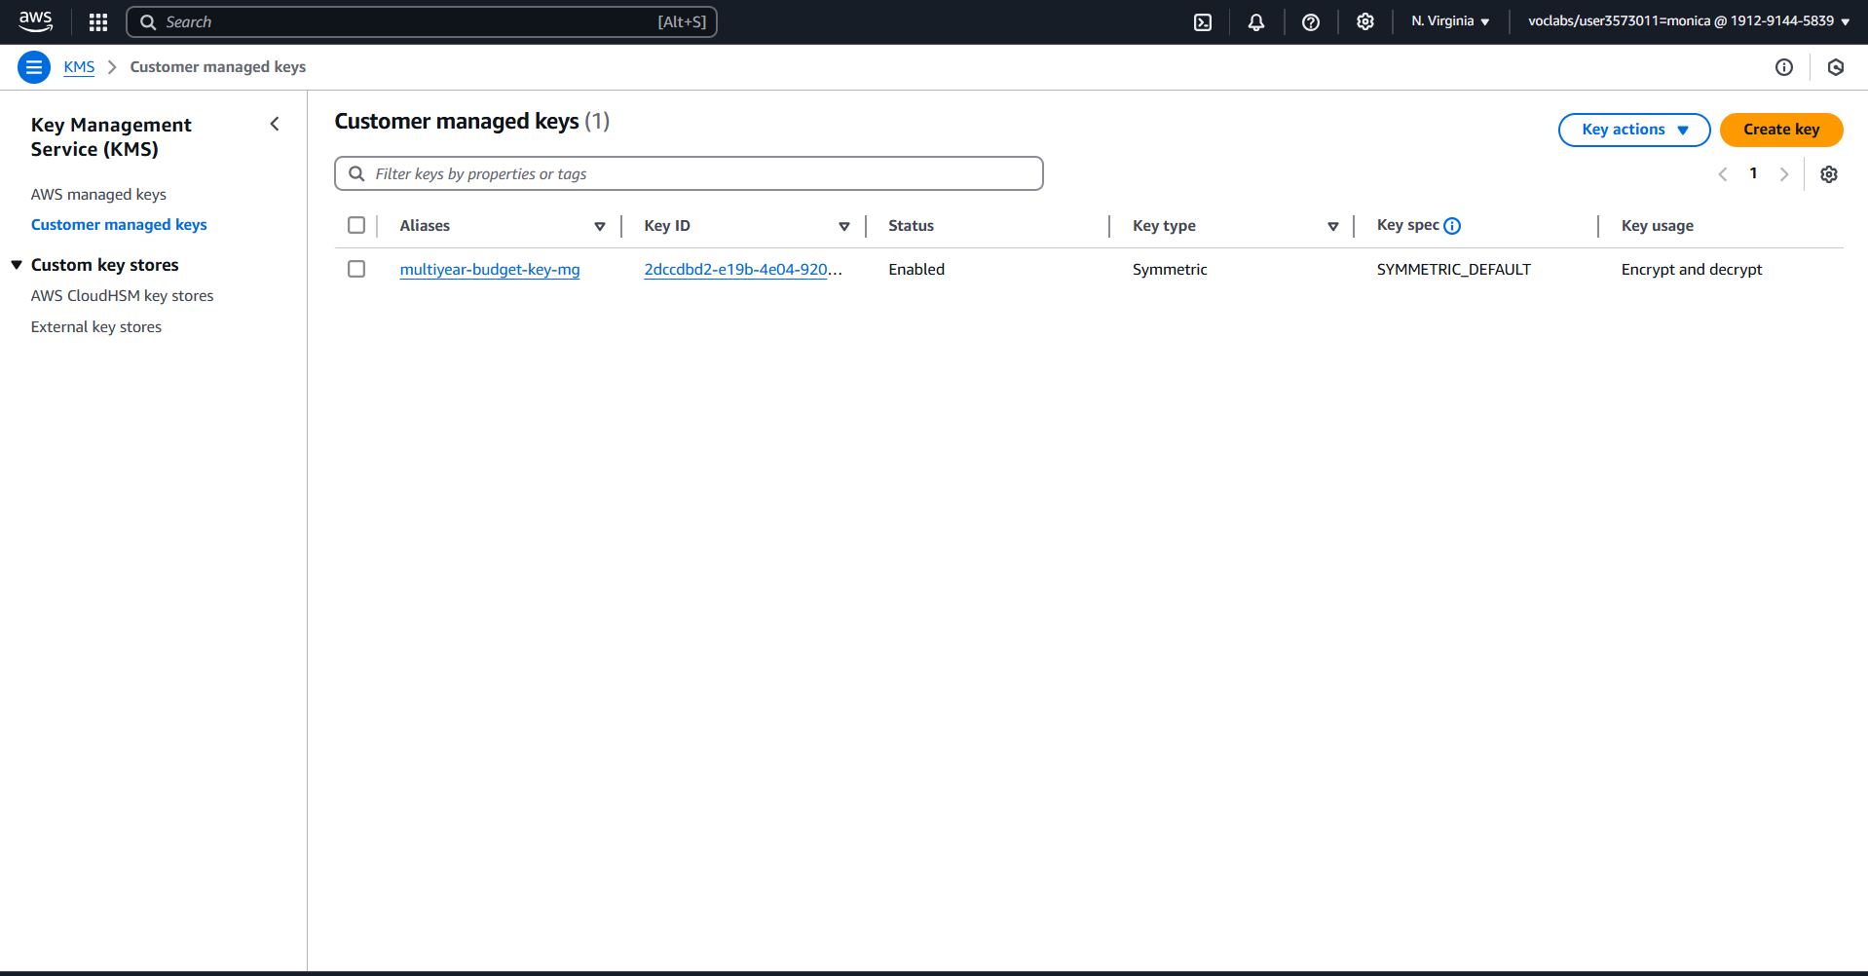

5. Data Governance and Observability

Data Replication: Ensured redundancy with the replication rule multiyear-budget-rep-mg, supporting disaster recovery and business continuity.

Lifecycle Policies: Transitioned older data to lower-cost storage like Glacier, reducing expenses while complying with retention policies.

AWS CloudWatch:

Enabled monitoring with metrics and alarms for S3 activities, system health, and billing.

Dashboards provided centralized monitoring for resource utilization and operational insights.

Insight:

These strategies optimize performance and cost while improving reliability and visibility into project operations.

6. Operational Excellence

Automated Workflows: AWS Glue pipelines streamline repetitive ETL tasks, while CloudTrail supports compliance audits.

Real-Time Monitoring: CloudWatch dashboards and alarms proactively address operational inefficiencies.

Key Insight:

Automation and real-time observability minimize manual overhead while boosting efficiency and system reliability.

7. Trends and Key Findings

Reliability and Cost Optimization:

Multi-region replication improves data availability, while lifecycle policies optimize storage costs.

2024 Annual Expenditure Analysis:

Aggregated data analysis supports direct comparisons between annual expenditures by region and allocated budgets for actionable insights.

Security and Sustainability:

Serverless architectures, data encryption, and observability tools align with sustainable and secure cloud computing practices.

Key Takeaways

This project demonstrates:

Strategic Budget Allocation: A robust framework for analyzing and comparing regional expenditures against set budgets.

Advanced Cloud Infrastructure: Leveraging AWS tools ensures scalability, security, and operational efficiency.

Sustainable Practices: Lifecycle policies and serverless architectures emphasize cost savings and energy efficiency.

Data Wrangler

Data wrangling, on the other hand, is the transformation process, which is turning data sets from the City of Vancouver from the raw form into a manner that can be analyzed with all the structures. Among the different phases in data wrangling are bringing in data from AWS S3 or CSV files and working on misunderstandings like the course of action of missing or null values-evicting fields that have no significance can be done by exchanging them; consistency of the data is to be set up (for example, the currency format of the budget field). The work of aggregation is done by means of summing up the money met by a single service in a year or an area. Programming languages such as Python (Pandas, Numpy) or AWS DataBrew are used to ensure that Wrangling is an effective Analytical Workflow.

Data control Quality:

Data quality control is the process that ensures the dataset of the City of Vancouver is accurate, consistent, reliable, and more importantly, timely. The most critical parts of data profiling are the downloading of the entire data set and the use of statistical methods to identify such as missing values, duplicates, or anomalies. Among the checks, we can find budget totals are verified with the source records that are fed into the database, and category labels are consistent. The data is checked against fraud with automated pipelines flagging the flaws during the transformations. Tools such as DataBrew or CloudTrail help monitor data changes on AWS, while encryption and access controls are used to ensure security. Compliance with governance standards is made certain through regular audits, and storage is optimally managed through lifecycle policies. Quality control, in the end, helps create trust in the data, which in turn is the basis for correct city planning

